**Practical File**

***Lab Name…COA LAB……. Lab Code……………***

.



**Name –SURAJ BHATT**

**Adm.No...2019b111005... Univ. Roll No...1900321290064…**

**Course …b.tech … Branch…ceit...**

**Sem…second…. Section…………..**



Pratical-6

**AIM:-** Verify the excitation tables of various FLIP-FLOPS

**Theory:** Logic circuits for digital systems are either combinational or sequential. The output of combinational circuits depends only on the current inputs. In contrast, sequential circuit depends not only on the current value of the input but also upon the internal state of the circuit. Basic building blocks (memory elements) of a sequential circuit are the flip-flops (FFs). A flip-flop is a device which stores a single *bit* (binary digit) of data; one of its two states represents a "one" and the other represents a "zero". Such data storage can be used for storage of *state*, and such a circuit is described as sequential logic

There are four Flip-Flops as follows-

* SR Flip-Flop
* D Flip-Flop
* JK Flip-Flop
* T Flip-Flop

## SR Flip-Flop

SR flip-flop operates with only positive clock transitions or negative clock transitions. Whereas, SR latch operates with enable signal.

**Block Diagram of SR Flip Flop & Pin Diagram:**

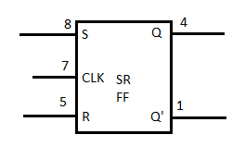

The **circuit diagram** of SR flip-flop is shown in the following figure.

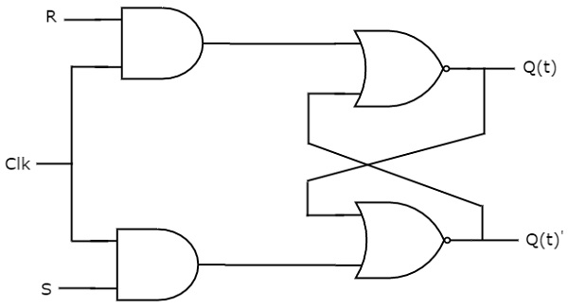

This circuit has two inputs S & R and two outputs Qt & Qt’. The operation of SR flipflop is similar to SR Latch. But, this flip-flop affects the outputs only when positive transition of the clock signal is applied instead of active enable.

The following table shows the **state table** of SR flip-flop.

|  |  |  |
| --- | --- | --- |
| **S** | **R** | **Q**t+1 |
| 0 | 0 | Qt |
| 0 | 1 | 0 |
| 1 | 0 | 1 |
| 1 | 1 | - |

Here, Qt & Qt+1 are present state & next state respectively. So, SR flip-flop can be used for one of these three functions such as Hold, Reset & Set based on the input conditions, when positive transition of clock signal is applied. The following table shows the **characteristic table** of SR flip-flop.

|  |  |  |  |
| --- | --- | --- | --- |
| **Present Inputs** | | **Present State** | **Next State** |
| **S** | **R** | **Q**t | **Q**t+1 |
| 0 | 0 | 0 | 0 |
| 0 | 0 | 1 | 1 |
| 0 | 1 | 0 | 0 |
| 0 | 1 | 1 | 0 |
| 1 | 0 | 0 | 1 |
| 1 | 0 | 1 | 1 |
| 1 | 1 | 0 | x |
| 1 | 1 | 1 | x |

The **simplified expression** for next state Qt+1 is

Q(t+1)=S+R′Q(t)Q(t+1)=S+R′Q(t)

## D Flip-Flop

D flip-flop operates with only positive clock transitions or negative clock transitions. Whereas, D latch operates with enable signal. That means, the output of D flip-flop is insensitive to the changes in the input, D except for active transition of the clock signal.

**Block Diagram of SR Flip Flop & Pin Diagram**

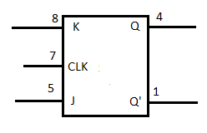

The **circuit diagram** of D flip-flop is shown in the following figure.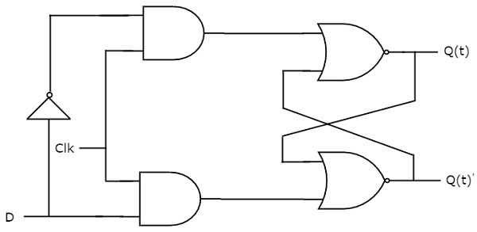

This circuit has single input D and two outputs Qtt &Qtt’. The operation of D flip-flop is similar to D Latch. But, this flip-flop affects the outputs only when positive transition of the clock signal is applied instead of active enable.

The following table shows the **state table** of D flip-flop.

|  |  |
| --- | --- |
| **D** | **Qt + 1t + 1** |
| 0 | 0 |
| 1 | 1 |

Therefore, D flip-flop always Hold the information, which is available on data input, D of earlier positive transition of clock signal. From the above state table, we can directly write the next state equation as

Qt+1t+1 = D

Next state of D flip-flop is always equal to data input, D for every positive transition of the clock signal. Hence, D flip-flops can be used in registers, **shift registers** and some of the counters.

## JK Flip-Flop

JK flip-flop is the modified version of SR flip-flop. It operates with only positive clock transitions or negative clock transitions.

**Block Diagram of SR Flip Flop & Pin Diagram**



The **circuit diagram** of JK flip-flop is shown in the following figure.

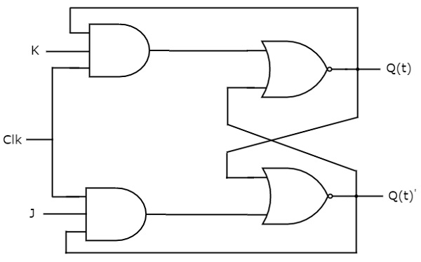

This circuit has two inputs J & K and two outputs Qt & Qt’. The operation of JK flip-flop is similar to SR flip-flop. Here, we considered the inputs of SR flip-flop as **S = J Q**t**’** and **R = KQ**t in order to utilize the modified SR flip-flop for 4 combinations of inputs.

The following table shows the **state table** of JK flip-flop.

|  |  |  |
| --- | --- | --- |
| **J** | **K** | **Q**t+1 |
| 0 | 0 | Qt |
| 0 | 1 | 0 |
| 1 | 0 | 1 |
| 1 | 1 | Qt' |

Here, Qt& Qt+1 are present state & next state respectively. So, JK flip-flop can be used for one of these four functions such as Hold, Reset, Set & Complement of present state based on the input conditions, when positive transition of clock signal is applied. The following table shows the **characteristic table** of JK flip-flop.

|  |  |  |  |
| --- | --- | --- | --- |
| **Present Inputs** | | **Present State** | **Next State** |
| **J** | **K** | **Q**t | **Q**t+1 |
| 0 | 0 | 0 | 0 |
| 0 | 0 | 1 | 1 |
| 0 | 1 | 0 | 0 |
| 0 | 1 | 1 | 0 |
| 1 | 0 | 0 | 1 |
| 1 | 0 | 1 | 1 |
| 1 | 1 | 0 | 1 |
| 1 | 1 | 1 | 0 |

The **simplified expression** for next state Qt+1 is

Q(t+1)=JQ(t)′+K′Q(t)Q(t+1)=JQ(t)′+K′Q(t)

## T Flip-Flop

T flip-flop is the simplified version of JK flip-flop. It is obtained by connecting the same input ‘T’ to both inputs of JK flip-flop. It operates with only positive clock transitions or negative clock transitions.

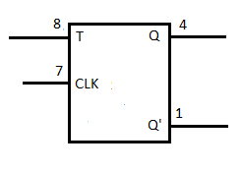

The **circuit diagram** of T flip-flop is shown in the following figure.

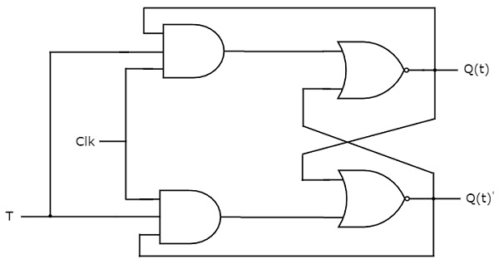

This circuit has single input T and two outputs Qtt &Qtt’. The operation of T flip-flop is same as that of JK flip-flop. Here, we considered the inputs of JK flip-flop as **J = T** and **K = T** in order to utilize the modified JK flip-flop for 2 combinations of inputs. So, we eliminated the other two combinations of J & K, for which those two values are complement to each other in T flip-flop.

The following table shows the **state table** of T flip-flop.

|  |  |
| --- | --- |
| **T** | **Q**t+1 |
| 0 | Qt |
| 1 | Qt’ |

Here, Qt & Qt+1 are present state & next state respectively. So, T flip-flop can be used for one of these two functions such as Hold, & Complement of present state based on the input conditions, when positive transition of clock signal is applied. The following table shows the **characteristic table** of T flip-flop.

|  |  |  |
| --- | --- | --- |
| **Inputs** | **Present State** | **Next State** |
| **T** | **Q**t | **Q**t+1 |
| 0 | 0 | 0 |
| 0 | 1 | 1 |
| 1 | 0 | 1 |
| 1 | 1 | 0 |

From the above characteristic table, we can directly write the **next state equation** as

Q(t+1)=T′Q(t)+TQ(t)′Q(t+1)=T′Q(t)+TQ(t)′

⇒Q(t+1)=T⊕Q(t)⇒Q(t+1)=T⊕Q(t)

The output of T flip-flop always toggles for every positive transition of the clock signal, when input T remains at logic High 11. Hence, T flip-flop can be used in **counters**.

In this chapter, we implemented various flip-flops by providing the cross coupling between NOR gates. Similarly, you can implement these flip-flops by using NAND gates.

IMPLEMENTATION:

